

**MODULE:**

**INTRODUCTION TO PROGRAMMING**

**JANUARY 2018**



**Important Notes:**



* Please refer to the Assignment Presentation Requirements for advice on how to set out your assignment. These can be found on the NCC Education *Campus*. Scroll down the left hand side of the screen until you reach Personal Support. Click on this, and then on Policies and Advice. You will find the Assignment Presentation Requirements under the Advice section.
* You must familiarize yourself with the NCC Education Academic Dishonesty and Plagiarism Policy and ensure that you acknowledge all the sources which you use in your work. The policy is available on *Campus*. Follow the instructions above, but click on Policies rather than Advice.
* You must complete the **‘Statement and Confirmation’**. The form is available on the Policies section of *Campus*. Scroll down the left hand side until you reach Personal Support. Click on this and then click on Policies and Advice.
* You must submit a paper copy and digital copy (on disk or similarly acceptable medium). Media containing viruses, or media which cannot be run directly, will result in a fail grade being awarded for this module.
* All electronic media will be checked for plagiarism.
* This assessment is worth **100%** of the student’s overall grade.

|  |  |  |
| --- | --- | --- |
| Student Name:  Fahad Md. Kamal | Student Number: 00171328 | Centre: DIA |

**Marker's comments:**

**Moderator's comments:**

|  |  |  |
| --- | --- | --- |
| **Mark:** | **Moderated** | **Final** |
|  | **Mark:** | **Mark:** |





|  |  |
| --- | --- |
| ***Each time you submit an assignment you must attach this statement as the cover page for both the hard copy and the electronic version. If the statement is missing your work will not be marked.*** | |
| Student Declaration | |
| I have read and understood NCC Education’s Policy on Academic Dishonesty and Plagiarism.  I can confirm the following details: | |
| Student ID/Registration number: | 00171328 |
| Name: | Fahad Md. Kamal |
| Centre Name: | Daffodil International Academy (DIA) |
| Module Name: | Introduction To Programming (ITP) |
| Module Leader: | Rakibul Hasan |
| Number of words: |  |
| I confirm that this is my own work and that I have not plagiarized any part of it. I have also noted the assessment criteria and pass mark for assignments. | |
| Due Date: | 02.11.2017 |
| Student Signature: |  |
| Submitted Date: | 9.11.2017 |



Table of Contents

Acknowledgement: 2

Introduction: 2

System Design: 2

List of Requirements: 3

Logical UI (User Interface) Design: 7

Personal Information Graphical Design: 8

Wonderful Walks “Selection Page” Design Details: 9

Personal Information Page: 11

System Development: 12

Splash Page with Progress bar: 12

Selection Page: 13

Various Methods: 22

Object Definition Sheet: 23

System Testing: 35

# Acknowledgement:

My heartiest thanks to my course instructor for giving all the support during the course and after the course. He really helped me a lot while doing the project. Without this support it was quite impossible for me to do this assignment with the because it seemed very difficult in beginning. However, now it has become very easy for us.

# Introduction:

The task we were given to build an application for Wonderful Walks with whom its customers can choose the journey and location or other facilities. For this job I have used labels, text boxes, check boxes, buttons, Picture boxes and check list box. Customers will have to choose different options and will see the summary of choices with the prices. If agrees a new form will show up and there they will have to fill their personal information and 16 Digits Debit / Credit card number.

# System Design:

The project that I have created during my assignment follows a systematic way on demanding the software’s need. However, here I am going to divide my assignment into 3 parts.

* + - * **List of Requirements**
      * **Flowchart**
      * **Logical UI (User Interface) Design**

# List of Requirements:

To define the requirements that will be addressed by the project are given below:

1. Users must have to choose one item form the combo box of “Walking Durations”.
2. Users must have to choose one “Walking Location” from the 2nd combo box.
3. Users must have to choose one “Accommodation Type” from the 3rd combo box.
4. Users must have to choose one “Luggage carry option” from the 4th combo box.
5. Users must have to choose one “Food option” from the 5th combo box.
6. Customers may also choose any items from the additional items check list box.
7. Program must check the stock limit of each group of people if it is available or not. If not than it will prompt the user to select another category.
8. During the process if the customer selects reset image box all the selection will reset.
9. If the customer wants to see the price lists they can see by clicking on the picture box beside the respective labels.
10. If the selection is finished than a message box will appear showing the selected items and their total price to be paid asking the user if he/she wishes to pay for the selected items.
11. If the user chooses “YES” another message box will appear thanking him and a new form will appear which will ask the user to fill his personal information and his credit or debit card number.
12. If the user keeps any text boxes blank than a message box will show up warning him/her.
13. If the length of the text-box’s text exceeds than message box will appear warning the user.
14. If the user inputs alphabetic data to the post code or in credit/debit card number text boxes message box will appear showing the warning that these inputs cannot have string data.
15. If there is white space in the “post code or credit/ debit card number” text box a warning message box will appear telling that respective data cannot have space.
16. If the credit/ Debit card number is not in 16 digits than a message box will show up warning the user “Please enter your 16-digit Credit/ Debit card number.”
17. When everything is fulfilled and the customer click the button submit a message box will appear thanking him/ her for the information.
18. However, customer can go back to the previous page any time by pressing the “BACK” button any time.

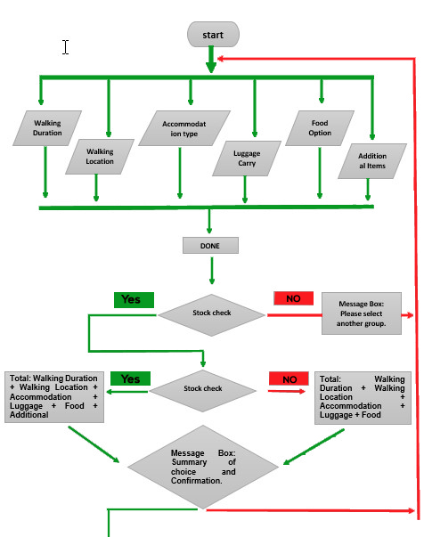

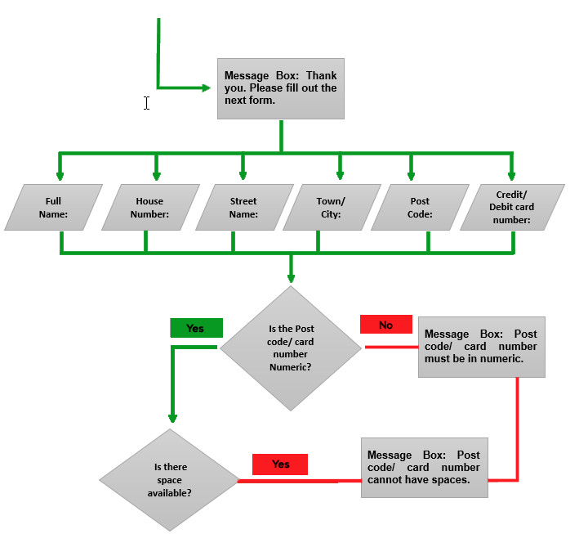

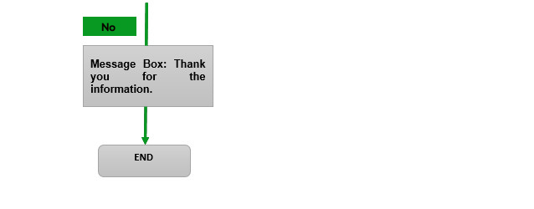

Figure 1: Program's working flowchart

# Logical UI (User Interface) Design:

Here is the user’s graphical interface of the project.

**Wonderful Walks “Selection Page” Graphical Design:**

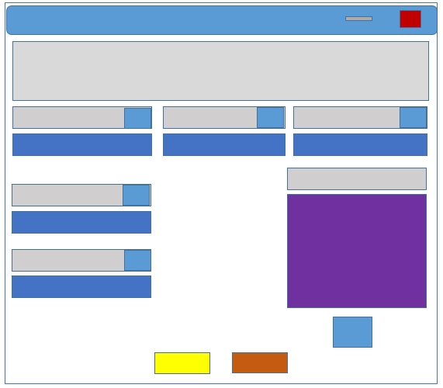

Figure 2: Selection Page

## Personal Information Graphical Design:

Figure 3: Personal Information Page

# Wonderful Walks “Selection Page” Design Details:

**Wonderful Walks (Label):** The project name is here. Graphical interface color is "Gray" (in Figure 3) on this (.docx) file.

**Walking Duration (Label and Combo box):** Customers must select any of the walking duration from this Combo Box. Graphical interface color of the combo box is "Blue” and the label holding the purpose is in “Gray” (in Figure 3) on this (.docx) file.

**Walking Location (Label and Combo box):** Customers must select any of the walking location from this Combo Box. Graphical interface color of the combo box is "Blue” and the label holding the purpose is in “Gray” (in Figure 3) on this (.docx) file.

**Accommodation Type (Label and Combo Box):** Customers must select any of the accommodation type from this Combo Box. Graphical interface color of the combo box is "Yellow” and the label holding the purpose is in “Gray” (in Figure 3) on this (.docx) file.

**Luggage Carrying Option (Label and Combo Box):** Customers must select any of the Luggage Carrying Option from this Combo Box. Graphical interface color of the combo box is "Blue” and the label holding the purpose is in “Gray” (in Figure 3) on this (.docx) file.

**Food Option (Label and Combo Box):** Customers must select any of the Food Option from this Combo Box. Graphical interface color of the combo box is " Blue” and the label holding the purpose is in “Gray” (in Figure 3) on this (.docx) file.

**Additional Items (Label and Check List Box):** Customers can select any of the additional items from this Check List Box. Graphical interface color of the Check list box is " Pupal” and the label holding the purpose is in “Gray” (in Figure 3) on this (.docx) file.

**Button DONE:** After complete of selection if the customers click the done button the program will show the summary of choice and price total. It will ask the customer if he/ she wishes to pay. And if the user agrees the program will run forward. Graphical interface color of the button Done is "Orange” (in Figure 3) on this (.docx) file.

**Button Exit:** If the user wants to completely Exit from the program he/ she can stop it by pressing the EXIT button. Graphical interface color of the button Done is "Yellow” (in Figure 3) on this (.docx) file.

**Page information:** In this page there is 5 combo boxes, 7 labels, 1 check list box, 2 buttons and 6 Picture box.

# Personal Information Page:

**Personal Information (Label):** The page name is here. Graphical interface color is "Gray" (in Figure 4) on this (.docx) file.

**Full Name (Label and Text box):** Customers must input their full name in string data type in this text box. Graphical interface color of the text box is "Blue” and the label holding the purpose is in "Gray" (in Figure 4) on this (.docx) file.

**Page info:** This page has 6 text boxes, 7 labels and 2 buttons. Graphical interface color of the text box is "Blue” and the label holding the purpose is in "Gray" (in Figure 4) on this (.docx) file.

**Button SUBMIT:** After filling out the form with the correct information customer can finally submit their order and pay for it by pressing the Submit button. A message box will show up thanking him/ her for the information. Graphical interface color of the button Done is "Virgo” (in Figure 4) on this (.docx) file.

**Button BACK:** And if the user wants to go back to the previous page he/ she can do it by pressing the Back Button. Graphical interface color of the button Done is "Black” (in Figure 4) on this (.docx) file.

**Button Exit:** And if the user wants to exit the program he/ she can do it by pressing the Exit Button. Graphical interface color of the button Done is "Pink” (in Figure 4) on this (.docx) file.

# System Development:

The way which is adopted throughout the developing process which means designing, testing, defining and implementing the project. During the implementation of this Wonderful Walks I have to use various codes and values which were needed for this project.

## Splash Page with Progress bar:

'00171328_Fahad_Md_Kamal_IFY_ITP_January_2018

Public Class SpleshScreenOfWonderful_Walks

Private Sub SpleshScreenOfWonderful_Walks_Load(sender As Object, e As EventArgs) Handles MyBase.Load

'Starting Timer

tmr_1.Start()

End Sub

Private Sub tmr_1_Tick(sender As Object, e As EventArgs) Handles tmr_1.Tick

'Increamenting Progress Bar

ProgBar.Value += 1

'Showing the Progress bars parcentage on lable.

If ProgBar.Value = 8 Then

lblCmpnyName.Text = "Welcome To"

End If

If ProgBar.Value = 50 Then

lblCmpnyName.Text = "Wonderful Walks"

End If

If ProgBar.Value = 60 Then

lblScottishHighlands.Text = "Scottish Highlands"

End If

If ProgBar.Value = 60 Then

lblDvlpr.Text = "Developer"

End If

If ProgBar.Value = 80 Then

lblDvlpr.Text = "00171328_Fahad_Md_Kamal_IFY_ITP_January_2018"

End If

If ProgBar.Value = 100 Then

'stopping the timer

tmr_1.Stop()

'Selection Page Show UP

Home_Page.Show()

'Closing the Splash screen

Me.Close()

End If

lbl_Percentage.Text = ProgBar.Value

End Sub

End Class

|  |
| --- |
| **These are the codes for the splash screen and progress bar with timer. This codes will be executed when the program will start to run.** |

# Home Page:

'''''''''''''''''''''''''''''''''' 00171328_Fahad_Md_Kamal_IFY_ITP_January_2018 '''''''''''''''''''''''''''''''''''''''''

Public Class Home_Page

'''''''''''''''''''''''''''''''''''''''''''''''' Declaring Golbal arrays '''''''''''''''''''''''''''''''''''''

Dim PriceDuration() As Integer = {0, 0, 0, 0}

Dim PriceLocation() As Integer = {0, 30, 20, 30}

Dim PriceAccomodation() As Integer = {0, 40, 60, 10}

Dim PriceLuggage() As Integer = {0, 0, 30}

Dim PriceFood() As Integer = {0, 10, 20, 25, 30, 20}

''''''''''''''''''''''''''''''''''''''''' Declaring Additional Items Price Arrays ''''''''''''''''''''''''''''''''''''''''

Dim PriceAdditional() As Integer = {5, 10, 5, 20, 30}

'''''''''''''''''''''''''''''''''''''''''''''''' Declaring Group Stock ''''''''''''''''''''''''''''''''''''

Dim Group3D As Integer = 16

Dim Group5D As Integer = 16

Dim Group10D As Integer = 16

|  |
| --- |
| **These codes were used to declare Prices of the products and Stock of each group.** |

Private Sub Home_Page_Load(sender As Object, e As EventArgs) Handles MyBase.Load

''''''''''''''''''''''''''''''''''''''' Form Name Change during form load event. '''''''''''''''''''''''''''''''

Me.Text = ("Wonderful Walks")

'''''''''''''''''''''''''''''''' Walking Duration options items adding to the ComboBox ''''''''''''''''''''''''''''''''''''

cmbWalkingDuration.Items.Add("Select")

cmbWalkingDuration.Items.Add("3 Days")

cmbWalkingDuration.Items.Add("5 days")

cmbWalkingDuration.Items.Add("10 days")

cmbWalkingDuration.SelectedIndex = 0

''''''''''''''''''''''''''''''''''' Walking Location options items adding to the ComboBox ''''''''''''''''''''''''''''''''''''

cmbWalkingLocation.Items.Add("Select")

cmbWalkingLocation.Items.Add("Trossachs")

cmbWalkingLocation.Items.Add("Great Glen")

cmbWalkingLocation.Items.Add("West Highland Way")

cmbWalkingLocation.SelectedIndex = 0

'''''''''''''''''''''''''''''''''''''''''''' Accommodation options adding to the ComboBox ''''''''''''''''''''''''''''''''''''

cmbAccommodationOptions.Items.Add("Select")

cmbAccommodationOptions.Items.Add("Camping")

cmbAccommodationOptions.Items.Add("Youth Hostel")

cmbAccommodationOptions.Items.Add("Bed & Breakfast")

cmbAccommodationOptions.SelectedIndex = 0

''''''''''''''''''''''''''''''''''''''''''' Luggage carry options items adding to the ComboBox ''''''''''''''''''''''''''''''''''''

cmbLuggageCarry.Items.Add("Select")

cmbLuggageCarry.Items.Add("Carry Own Luggage")

cmbLuggageCarry.Items.Add("Transported Luggage")

cmbLuggageCarry.SelectedIndex = 0

'''''''''''''''''''''''''''''''''''''''''''' Food options items adding to the ComboBox ''''''''''''''''''''''''''''''''''''

cmbFoodOption.Items.Add("Select")

cmbFoodOption.Items.Add("Self-Catering")

cmbFoodOption.Items.Add("Catered Vegetarian")

cmbFoodOption.Items.Add("Catered Regular")

cmbFoodOption.Items.Add("Catered Gluten Free")

cmbFoodOption.Items.Add("Catered Lactose Free")

cmbFoodOption.SelectedIndex = 0

|  |
| --- |
| **These codes are used to add items in Combo Boxes of “Walking Duration, Walking Location, Accommodation, Luggage Carry Option and Food Option during Form load event.** |

'''''''''''''''''''''''''''''''''''''''''' Adding additional Items to the checklistbox '''''''''''''''''''''''''''''''''''''''''''

chklstAdditional_Items.Items.Add("Solar charger : £5")

chklstAdditional_Items.Items.Add("Walking poles (pair) : £10")

chklstAdditional_Items.Items.Add("Mosquito net : £5")

chklstAdditional_Items.Items.Add("2-man tent : £20")

chklstAdditional_Items.Items.Add("4-man tent : £30")

End Sub

|  |
| --- |
| **These codes were used to add Additional Items in Check List Box during Form load event.** |

Private Sub btnDONE_Click_1(sender As Object, e As EventArgs) Handles btnDONE.Click

''''''''''''''''''''''''''''''''''''''''''''' Declaring Veriable ''''''''''''''''''''''''''''''''''''''''''''''''''''''''''

Dim MainOutput, AddOutput, MsgOutput As String

Dim MainPrice, MainTotal, AddTotal, GrandTotal As Integer

MainOutput = ""

AddOutput = ""

'''''''''''''''''''''''''''''''''''''''''''' Walking Duration selection actions '''''''''''''''''''''''''''''''''''''''''

If cmbWalkingDuration.SelectedIndex < 1 Then

MessageBox.Show("You have to select a Walking duration.", "Error", MessageBoxButtons.OK, MessageBoxIcon.Error)

Exit Sub

Else MainOutput += "Selected duration : " + cmbWalkingDuration.SelectedItem & vbCrLf

MainPrice += PriceDuration(cmbWalkingDuration.SelectedIndex)

End If

'''''''''''''''''''''''''''''''''''''''''''' WalkingLocation selection actions ''''''''''''''''''''''''''''''''''''''

If cmbWalkingLocation.SelectedIndex < 1 Then

MessageBox.Show("You have to select a Walking Location.", "Error", MessageBoxButtons.OK, MessageBoxIcon.Error)

Exit Sub

Else MainOutput += "Selected Location : " + cmbWalkingLocation.SelectedItem & vbCrLf

MainPrice += PriceLocation(cmbWalkingLocation.SelectedIndex)

End If

'''''''''''''''''''''''''''''''''''''''''''''''''''''' Accommodation selection Actions ''''''''''''''''''''''''''''''''''''''''''''''''''''

If cmbAccommodationOptions.SelectedIndex < 1 Then

MessageBox.Show("You have to select an Accommodation Type.", "Error", MessageBoxButtons.OK, MessageBoxIcon.Error)

Exit Sub

Else MainOutput += "Selected Accommodation Type : " + cmbAccommodationOptions.SelectedItem & vbCrLf

MainPrice += PriceAccomodation(cmbAccommodationOptions.SelectedIndex)

End If

''''''''''''''''''''''''''''''''''''''''''''''''''''' Luggage Carry selection Actions ''''''''''''''''''''''''''''''''''''''''''

If cmbLuggageCarry.SelectedIndex < 1 Then

MessageBox.Show("You have to select Luggage Carry Option.", "Error", MessageBoxButtons.OK, MessageBoxIcon.Error)

Exit Sub

Else MainOutput += "Selected Luggage Carry Option : " + cmbLuggageCarry.SelectedItem & vbCrLf

MainPrice += PriceLuggage(cmbLuggageCarry.SelectedIndex)

End If

'''''''''''''''''''''''''''''''''''''''''''''''''''''Food Option selection actions '''''''''''''''''''''''''''''''''''''''''''''

If cmbFoodOption.SelectedIndex < 1 Then

MessageBox.Show("You have to select Food Option.", "Error", MessageBoxButtons.OK, MessageBoxIcon.Error)

Exit Sub

Else MainOutput += "Selected Food Option : " + cmbFoodOption.SelectedItem & vbCrLf

MainPrice += PriceFood(cmbFoodOption.SelectedIndex)

End If

''''''''''''''''''''''''''''''''''''''''''''''''''''''''Group Stock Check''''''''''''''''''''''''''''''''''''''''''''''''''

If cmbWalkingDuration.SelectedIndex = 1 Then

Group3D = Group3D - 1

If Group3D < 0 Then

MessageBox.Show("Only 16 People are allowed in 3 days walking group ." & vbCrLf & vbCrLf & "Please select another group.", "Out of Stock!!!", MessageBoxButtons.OK, MessageBoxIcon.Stop)

Exit Sub

End If

End If

If cmbWalkingDuration.SelectedIndex = 2 Then

Group5D = Group5D - 1

If Group5D < 0 Then

MessageBox.Show("Only 16 People are allowed in 5 days walking group ." & vbCrLf & vbCrLf & "Please select another group.", "Out of Stock!!!", MessageBoxButtons.OK, MessageBoxIcon.Stop)

Exit Sub

End If

End If

If cmbWalkingDuration.SelectedIndex = 3 Then

Group10D = Group10D - 1

If Group10D < 0 Then

MessageBox.Show("Only 16 People are allowed in 10 days walking group ." & vbCrLf & vbCrLf & "Please select another group.", "Out of Stock!!!", MessageBoxButtons.OK, MessageBoxIcon.Stop)

Exit Sub

End If

End If

'''''''''''''''''''''''''''''''''' Additional Items Output '''''''''''''''''''''''''''''''''''''''''

For Each AdtItm In chklstAdditional_Items.CheckedItems

AddOutput += AdtItm & vbCrLf

Next

For Each CbxChk In chklstAdditional_Items.CheckedIndices

AddTotal += PriceAdditional(CbxChk)

Next

''''''''''''''''''''''''''''''''''''' Mathmetical Terms ''''''''''''''''''''''''''''''''''''''''''''

MainTotal += MainPrice

GrandTotal = MainTotal + AddTotal

''''''''''''''''''''''''''''' Output Formet ''''''''''''''''''''''''''''''''''''''''''''''''''''''''

MsgOutput = MainOutput & vbCrLf & vbCrLf & AddOutput & vbCrLf & "Total Cost : " & GrandTotal & " £"

''''''''''''''''''''''''''''''''' Confirmation MessegeBox & its button click actions '''''''''''''''''''''''''''''

Dim proment As DialogResult = MessageBox.Show(MsgOutput & vbCrLf & vbCrLf & "Do you want to pay for the Items that you've selected ?", "Summary Of Choices", MessageBoxButtons.YesNo, MessageBoxIcon.Information)

If proment = DialogResult.Yes Then

MessageBox.Show("Let's Go To The Final Form...!!", ">>>>>>>>>>> Thank You <<<<<<<<<<<", MessageBoxButtons.OK, MessageBoxIcon.None)

Payment_Confirmation_Page.Show()

Me.Close()

End If

End Sub

|  |
| --- |
| **These codes are to perform when the “DONE” button is clicked.** |

'''''''''''''''''''''''''''''''''''''''''''''''''' Walking Duration Price List '''''''''''''''''''''''''''''''''''''''''''''''''''''

Private Sub PB_WD_Click(sender As Object, e As EventArgs) Handles PB_WD.Click

MessageBox.Show("There is no Cost for Walking.", "GOOD NEWS ", MessageBoxButtons.OK, MessageBoxIcon.None)

End Sub

''''''''''''''''''''''''''''''''''' Walking Location Price List '''''''''''''''''''''''''''''''''''''''''''''''''''''''

Private Sub PB_WL_Click(sender As Object, e As EventArgs) Handles PB_WL.Click

Dim WLOtp As String

WLOtp = "Walking Location : Trossachs = 30 £ " & vbCrLf & "Walking Location : Great Glen = 20 £ " & vbCrLf & "Walking Location : West Highland Way = 30 £ "

MessageBox.Show(WLOtp, "Walking Location Price List", MessageBoxButtons.OK, MessageBoxIcon.Information)

End Sub

'''''''''''''''''''''''''''''''''''''' Accommodation Type Price list ''''''''''''''''''''''''''''''''''

Private Sub PB_ACC_Click(sender As Object, e As EventArgs) Handles PB_ACC.Click

Dim ACP As String

ACP = "Accommodation Type : Camping = 40 £ " & vbCrLf & "Accommodation Type : Youth Hostel = 60 £ " & vbCrLf & "Accommodation Type : Bed & Breakfast = 10 £ "

MessageBox.Show(ACP, "Accommodation Type Price List", MessageBoxButtons.OK, MessageBoxIcon.Information)

End Sub

'''''''''''''''''''''''''''''''''''' Luggage Carry Price List '''''''''''''''''''''''''''''

Private Sub PB_Lug_Click(sender As Object, e As EventArgs) Handles PB_Lug.Click

Dim LC As String

LC = "Carry Own Luggage : Free Of Cost " & vbCrLf & "Transported Luggage : 60 £ "

MessageBox.Show(LC, "Luggage Carry Price List", MessageBoxButtons.OK, MessageBoxIcon.Information)

End Sub

'''''''''''''''''''''''''''''''''''' Food Option Price List '''''''''''''''''''''''''''''''''

Private Sub PB_Food_Click(sender As Object, e As EventArgs) Handles PB_Food.Click

Dim ACP As String

ACP = "Food Option : Self-Catering = 10 £ " & vbCrLf & "Food Option : Catered Vegetarian = 20 £ " & vbCrLf & "Food Option : Catered Regular = 25 £ " & vbCrLf & "Food Option : Catered Gluten Free = 30 £ " & vbCrLf & "Food Option : Catered Lactose Free = 20 £ "

MessageBox.Show(ACP, "Food Option Price List", MessageBoxButtons.OK, MessageBoxIcon.Information)

End Sub

Private Sub PB_ResetAll_Click(sender As Object, e As EventArgs) Handles PB_ResetAll.Click

For Each cmbx As Control In Me.Controls

If TypeOf cmbx Is ComboBox Then

cmbx.Text = "Select"

End If

Next

End Sub

End Class

|  |
| --- |
| **These codes are to be executed during the mouse hover and mouse click on the image box.** |

'''''''''''''''''''''''''''''''''''''''''''''''''' Exit button click action '''''''''''''''''''''''''''''''''''''''''''''''

Private Sub btnEXIT_Click(sender As Object, e As EventArgs) Handles btnEXIT.Click

MessageBox.Show("Thanks for visiting Wonderful Walks.", "Good Bye...!!")

Payment_Confirmation_Page.Close()

Me.Close()

End Sub

|  |
| --- |
| **These codes are to be executed while the exit button is clicked to close the program.** |

'''''''''''''''''''''''''''''' 00171328_Fahad_Md_Kamal_IFY_ITP_January_2018 '''''''''''''''''''''''''''''''

Public Class Payment_Confirmation_Page

Private Sub btnBack_Click(sender As Object, e As EventArgs) Handles btnBack.Click

'''''''''''''''''''''' Back Button Click Event Action ''''''''''''''''''''''''

MessageBox.Show("Going back to the selection page")

Home_Page.Show()

Me.Close()

End Sub

Private Sub btnDone_Click(sender As Object, e As EventArgs) Handles btnSubmit.Click

'''''''''''''''''''''' User name input Data validation '''''''''''''''

If txtFullName.Text = "" Then

ErrorProvider.SetError(txtFullName, "Please enter your full name.")

Exit Sub

ElseIf NumericCheck(txtFullName.Text) = True

ErrorProvider.SetError(txtFullName, "Name cannot be in numbers.")

Exit Sub

ElseIf txtFullName.TextLength < 4 Or txtFullName.TextLength > 20

ErrorProvider.SetError(txtFullName, "Please enter your full name in 4 to 10 charecters.")

Exit Sub

End If

''''''''''''''''''''''''' House Number input Data validation'''''''''''''''''''''''''''''''''''

If txtHouseNumber.Text = "" Then

ErrorProvider.SetError(txtHouseNumber, "Please enter your house number.")

Exit Sub

ElseIf txtHouseNumber.TextLength < 4 Or txtHouseNumber.TextLength > 20

ErrorProvider.SetError(txtHouseNumber, "Please enter your house number in 4 to 10 charecters.")

Exit Sub

End If

'''''''''''''''''''''''''' Street Name input Data validation ''''''''''''''''''''''''''''''''''''

If txtStreetName.Text = "" Then

ErrorProvider.SetError(txtStreetName, "Please enter your Street Name.")

Exit Sub

ElseIf txtStreetName.TextLength < 4 Or txtStreetName.TextLength > 20

ErrorProvider.SetError(txtStreetName, "Please enter your Street Name in 4 to 10 charecters.")

Exit Sub

End If

'''''''''''''''''''''''''''' Town Or City input Data validation '''''''''''''''''''''''''''''''''''''

If txtlblTownOrCity.Text = "" Then

ErrorProvider.SetError(txtlblTownOrCity, "Please enter your Town/ City name.")

Exit Sub

ElseIf txtlblTownOrCity.TextLength < 4 Or txtlblTownOrCity.TextLength > 20

ErrorProvider.SetError(txtlblTownOrCity, "Please enter your Town/ City name in 4 to 10 charecters.")

Exit Sub

End If

'''''''''''''''''''''''''' Post Code input Data validation '''''''''''''''''''''''''''''''''''''''''''

If txtPostCode.Text = "" Then

ErrorProvider.SetError(txtPostCode, "Please enter your Post Code.")

Exit Sub

ElseIf SpcChk(txtPostCode.Text) = True

ErrorProvider.SetError(txtPostCode, " Post Code cannot have any space.")

Exit Sub

ElseIf AlphabeticCheck(txtPostCode.Text) = True

ErrorProvider.SetError(txtPostCode, "Post Code must be in numbers.")

Exit Sub

ElseIf txtPostCode.TextLength < 4 Or txtPostCode.TextLength > 10

ErrorProvider.SetError(txtPostCode, "Please enter your Post Code in 4 to 10 charecters.")

Exit Sub

End If

''''''''''''''''''''' Credit Card Number input Data validation ''''''''''''''''''''''''''

If txtCardNumber.Text = "" Then

ErrorProvider.SetError(txtCardNumber, "Please enter your Cedrit/ Debit Card Number.")

Exit Sub

ElseIf SpcChk(txtCardNumber.Text) = True

ErrorProvider.SetError(txtCardNumber, "Cedrit/ Debit Card Number cannot have any space.")

Exit Sub

ElseIf AlphabeticCheck(txtCardNumber.Text) = True

ErrorProvider.SetError(txtCardNumber, "Cedrit/ Debit Card Number cannot have any Alphabet.")

Exit Sub

ElseIf txtCardNumber.TextLength <> 16

ErrorProvider.SetError(txtCardNumber, "Degits Cedrit/ Debit Card Number must be in 16 Degits.")

Exit Sub

End If

'''''''''''''''''''''''''''''''''''''' Thank you messagebox and button actions '''''''''''''''''''''''''''''''''''''''''

Dim thnqmsgbx As DialogResult = MessageBox.Show("Thank you for the information" & vbCrLf & vbCrLf & "See You Soon !!", ">>>>>>>>>> Thank you <<<<<<<<<<", MessageBoxButtons.OK, MessageBoxIcon.Information)

If thnqmsgbx = DialogResult.OK Then

Dim lastmsgbx As DialogResult = MessageBox.Show("Do you want to fill another ?", ">>>>>>>>>> Thank you <<<<<<<<<<", MessageBoxButtons.YesNoCancel, MessageBoxIcon.Information)

If lastmsgbx = DialogResult.Yes Then

Home_Page.Show()

Me.Close()

ElseIf lastmsgbx = DialogResult.No

Me.Close()

End If

End If

End Sub

Private Sub Payment_Confirmation_Page_Load(sender As Object, e As EventArgs) Handles MyBase.Load

Me.Text = "Wonderful Walks"

End Sub

Private Sub ClearText(sender As Object, e As EventArgs) Handles txtFullName.TextChanged, txtHouseNumber.TextChanged, txtStreetName.TextChanged, txtlblTownOrCity.TextChanged, txtPostCode.TextChanged, txtCardNumber.TextChanged

'''''''''''''''''''''''''''''''''''' Clearing Error provider icons '''''''''''''''''''''''''''''''''''

ErrorProvider.Clear()

End Sub

Private Sub btn_EXIT_Click(sender As Object, e As EventArgs) Handles btn_EXIT.Click

Home_Page.Close()

Me.Close()

End Sub

End Class

|  |
| --- |
| **These Codes are to instruct the customer how to fill the form and will lead the user to complete the form correctly.** |

# Various Methods:

''''''''''''''''''''''''''''''' 00171328_Fahad_Md_Kamal_IFY_ITP_January_2018 '''''''''''''''''''''''''''''''''''''

Module Various_Methods

''''''''''''''' Inside TexBox White Space checking '''''''''''''''''''''''''''

Function SpcChk(ByVal str As String) As Boolean

Dim oldStr, nwstr As String

oldStr = str

Dim chkresult As Boolean = False

For Spce = 0 To oldStr.Length - 1

nwstr = oldStr.Substring(Spce, 1)

If nwstr = " " Then

chkresult = True

End If

Next

Return chkresult

End Function

|  |
| --- |
| **These codes are to check Inside Text Box White Spaces.** |

''''''''''''''' Inside TexBox Numeric data checking '''''''''''''''''''''''''''

Function NumericCheck(ByVal str As String) As Boolean

Dim oldStr, nwstr As String

oldStr = str

Dim chkresult As Boolean = False

For Charecter = 0 To oldStr.Length - 1

nwstr = oldStr.Substring(Charecter, 1)

If IsNumeric(nwstr) Then

chkresult = True

End If

Next

Return chkresult

End Function

|  |
| --- |
| **These codes are to check Inside Text Box White Numbers.** |

''''''''''''''' Inside TexBox Alphabetic data checking '''''''''''''''''''''''''''

Function AlphabeticCheck(ByVal str As String) As Boolean

Dim oldStr, nwstr As String

oldStr = str

Dim chkresult As Boolean = False

For Charecter = 0 To oldStr.Length - 1

nwstr = oldStr.Substring(Charecter, 1)

If Not IsNumeric(nwstr) Then

chkresult = True

End If

Next

Return chkresult

End Function

End Module

|  |
| --- |
| **These codes are to check Inside Text Box Alphabets.** |

# Object Definition Sheet:

The list of the properties, values and events that I have used to implement this project:

|  |  |  |  |  |
| --- | --- | --- | --- | --- |
| No. | Type | Property | Value | Event Procedures |
| 1 | Form | Name  Back color  Font  Size  text  Background  image | SpleshPageOfWonderful_Walks  Control  Microsoft Sans Serif, 8pt, Regular  901, 503  SpleshPageOfWonderful_Walks  System.Drawing.Bitmap | Load |
| 2 | Label | Name  Back color  Fore Color  Font  Size  Auto size | lblCmpnyName  Transparent  Midnight Blue  Arial Rounded MT Bold, 60pt, style=Italic  734, 102  False |  |
| 3 | Label | Name  Back color  Fore Color  Font  Size  Auto size | lblScottishHighlands  Transparent  255, 128, 0  Arial Rounded MT Bold, 26.25pt, style=Italic  356, 53  False |  |
| 4 | Label | Name  Back color  Fore Color  Font  Size  Auto size | lblDvlpr  Transparent  Silver  Times New Roman, 12pt, style=Bold, Italic  384, 23  False |  |
| 5 | Label | Name  Back color  Fore Color  Font  Size  Text  Auto size | lbl_Percentage  Transparent  ButtonFace  Times New Roman, 20.25pt, style=Bold  46, 32  False |  |
| 6 | Progress bar | Name  Back Color  Fore Color  Size | ProgBar  Transparent  WhiteSmoke  102, 89 |  |
| 7 | Timer | Name  Interval | tmr_1  50 |  |
| 8 | Form | Name  Back color  Font  Size  text  Background  image | Selection_Page  Control  Times New Roman, 8.25pt, style=Bold  1008, 581  Selection_Page  System.Drawing.Bitmap | Load |
| 9 | Label | Name  Back Color  Fore Color  Font    Size  Text  Auto size | lblTitleBar  Transparent  DarkGreen  Times New Roman, 36pt, style=Bold, Italic  945, 62  Wonderful Walks  False |  |
| 10 | Label | Name  Back Color  Fore Color  Font  Size  Text  Auto size | lblWalkingDuration  Transparent  DarkGreen  Times New Roman, 18pt, style=Bold, Italic  274, 30  Walking Duration :  True |  |
| 12 | Label | Name  Back Color  Fore Color  Font  Size  Text  Auto size | lblWalkLocation  Transparent  DarkGreen  Times New Roman, 18pt, style=Bold, Italic  179, 30  Walk Location :  True |  |
| 13 | Label | Name  Back Color  Fore Color  Font  Size  Text  Auto size | lblAccommodation  Transparent  DarkGreen  Times New Roman, 15.75pt, style=Bold  274, 30  Accommodation :  True |  |
| 14 | Label | Name  Back Color  Fore Color  Font  Size  Text  Auto size | lblLuggage  Transparent  DarkGreen  Times New Roman, 15.75pt, style=Bold  115, 30  Luggage :  False |  |
| 15 | Label | Name  Back Color  Fore Color  Font  Size  Text  Auto size | lblFood  Transparent  DarkGreen  Times New Roman, 18pt, style=Bold, Italic  274, 30  Food :  False |  |
| 16 | Label | Name  Back Color  Fore Color  Font  Size  Text  Auto size | lblAdditionalItems  Transparent  DarkGreen  Times New Roman, 18pt, style=Bold, Italic  274, 33  Additional Items  False |  |
| 17 | Combo Box | Name  Back color  Fore Color  Font  Size | cmbWalkingDuration  MidnightBlue  Lime  Times New Roman, 18pt, style=Bold, Italic  273, 27 |  |
| 18 | Combo Box | Name  Back color  Fore Color  Font  Size | cmbWalkingLocation  HotTrack  Lime  Times New Roman, 18pt, style=Bold, Italic  273, 27 |  |
| 19 | Combo Box | Name  Back color  Fore Color  Font  Size | cmbAccommodation  MidnightBlue  Lime  Times New Roman, 18pt, style=Bold, Italic  273, 27 |  |
| 20 | Combo Box | Name  Back color  Fore Color  Font  Size | cmbLuggage  HotTrack  Lime  Times New Roman, 18pt, style=Bold, Italic  273, 27 |  |
| 21 | Combo Box | Name  Back color  Fore Color  Font  Size | cmbFood  HotTrack  Lime  Times New Roman, 18pt, style=Bold, Italic  273, 27 |  |
| 22 | Check List Box | Name  Back color  Font  Fore Color  Size | chklstAdditional_Items  HotTrack  Times New Roman, 18pt, style=Bold, Italic  FloralWhite  273, 130 |  |
| 23 | Button | Name  Image  Font  Fore Color  Text  Size | btnDONE  System.Drawing.Bitmap  Times New Roman, 15.75pt, style=Bold  White  &DONE  115, 38 | Click |
| 24 | Button | Name  Image  Font  Fore Color  Text  Size | btnEXIT  System.Drawing.Bitmap  Times New Roman, 21.75pt, style=Bold  White  E&XIT  102, 38 | Click |
| 25 | Picture Boxs | Name  Back color  Size mode  Size | PB_WD, PB_Lug, PB_Food, PB_WL, PB_ResetAll  Transparent  StretchImage  34, 27 |  |
| 26 | Label | Name  Back Color  Fore Color  Font  Size | lblResetAll  Transparent  DeepSkyBlue  Times New Roman, 12pt, style=Bold  153, 70 |  |
| 27 | Label | Name  Back Color  Image  Fore Color  Font  Size  Text  Auto size | lblTitleBar  Transparent  System.Drawing.Bitmap  Maroon  Times New Roman, 15.75pt, style=Bold  502, 41  Personal Information  False |  |
| 28 | Label | Name  Back Color  Image  Fore Color  Font  Size  Text  Auto size | lblFullName  Transparent  System.Drawing.Bitmap  Maroon  Times New Roman, 15.75pt, style=Bold  258, 33  Full Name :  True |  |
| 29 | Label | Name  Back Color  Image  Fore Color  Font  Size  Text  Auto size | lblhousenumber  Transparent  System.Drawing.Bitmap  Maroon  Times New Roman, 15.75pt, style=Bold  258, 33  House Number :  True |  |
| 30 | Label | Name  Back Color  Image  Fore Color  Font  Size  Text  Auto size | lblstreetName  Transparent  System.Drawing.Bitmap  Maroon  Times New Roman, 15.75pt, style=Bold  258, 33  Street Name :  True |  |
| 31 | Label | Name  Back Color  Image  Fore Color  Font  Size  Text  Auto size | lblTownOrCity  Transparent  System.Drawing.Bitmap  Maroon  Times New Roman, 15.75pt, style=Bold  258, 33  Additional Items  True |  |
| 32 | Label | Name  Back Color  Image  Fore Color  Font  Size  Text  Auto size | lblPostCode  Transparent  System.Drawing.Bitmap  Maroon  Times New Roman, 15.75pt, style=Bold  258, 33  Post Code :  True |  |
| 33 | Label | Name  Back Color  Image  Fore color  Font  Size  Text  Auto size | lblCardNumber  Transparent  System.Drawing.Bitmap  Maroon  Times New Roman, 15.75pt, style=Bold  258, 33  Credit/ Debit Card :  False |  |
|  | ErrorProvider | Name  Blink Rate  Modifiers | ErrorProvider  250  Friend |  |
| 34 | Text Box | Name  Back color  Fore Color  Border style  Font  Size | txtFullName  GradientActiveCaption  Maroon  Fixed3D  Times New Roman, 12pt, style=Bold  258, 26 |  |
| 35 | Text Box | Name  Back color  Fore Color  Border style  Font  Size | txtHouseNumber  GradientActiveCaption  Maroon  Fixed3D  Times New Roman, 12pt, style=Bold  258, 26 |  |
| 36 | Text Box | Name  Back color  Fore Color  Border style  Font  Size | txtStreetName  GradientActiveCaption  Maroon  Fixed3D  Times New Roman, 12pt, style=Bold  258, 26 |  |
| 37 | Text Box | Name  Back color  Fore Color  Border style  Font  Size | txtTownOrCity  GradientActiveCaption  Maroon  Fixed3D  Times New Roman, 12pt, style=Bold  258, 26 |  |
| 38 | Text Box | Name  Back color  Fore Color  Border style  Font  Size | txtPostCode  GradientActiveCaption  Maroon  Fixed3D  Times New Roman, 12pt, style=Bold  258, 26 |  |
| 39 | Text Box | Name  Back color  Fore Color  Border style  Font  Size | txtCardNumber  GradientActiveCaption  Maroon  Fixed3D  Times New Roman, 12pt, style=Bold  258, 26 |  |
| 40 | Button | Name  Back color  Image  Font  Fore Color  Text  Size | btnBack  ActiveBorder  System.Drawing.Bitmap  Times New Roman, 15.75pt, style=Bold  Transparent  BACK  110, 46 | Click |
| 41 | Button | Name  Back color  Image  Font  Fore Color  Text  Size | btnSubmit  ActiveBorder  System.Drawing.Bitmap  Times New Roman, 15.75pt, style=Bold  Transparent  E&XIT  106, 46 | Click |
|  | Button | Name  Back color  Image  Font  Fore Color  Text  Size | btn_EXIT  ActiveBorder  System.Drawing.Bitmap  Times New Roman, 15.75pt, style=Bold  Transparent  BACK  106, 46 |  |

# System Testing:

Whenever a software is implemented it needs to be tested before it is used by the users. By testing the newly implemented software one can find out if there are any errors in the code or any other part of the codes. In order to find out the errors I am going to find out whether there is any errors in the codes of this newly implemented software.

1. **Testing Combo Box, Textbox and Check List box: Frame Width, Frame type, Form load:**

|  |  |  |  |
| --- | --- | --- | --- |
| **Prefix** | **Objectives** | **Testing Procedure** | **Result** |
| cmbWalkingDuration cmbWalkingLocation  cmbAccommodation cmbLuggage  cmbFood  chklstAdditional_Items | Checking whether these Combo box and Check list box works well or not. | Started the program and started to select items form the combo boxes and check list boxes. | All the boxes are working fluently. |

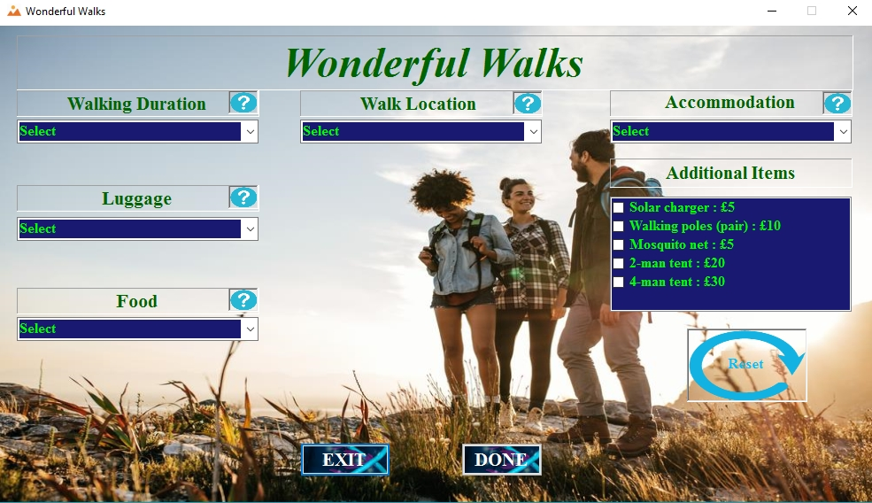

Figure 4

1. **Testing the Deselected Combo Box:**

|  |  |  |  |
| --- | --- | --- | --- |
| **Prefix** | **Objectives** | **Testing Procedure** | **Result** |
| Combo Box Deselected | Keeping the Combo box deselected user need to press the “DONE” button. | Keeping at list one of the combo box deselected user have to click the button “DONE” to check the result. | After pressing the button ”DONE” a message box shows up warning the user the he/ she must have to select one of the respective item. |

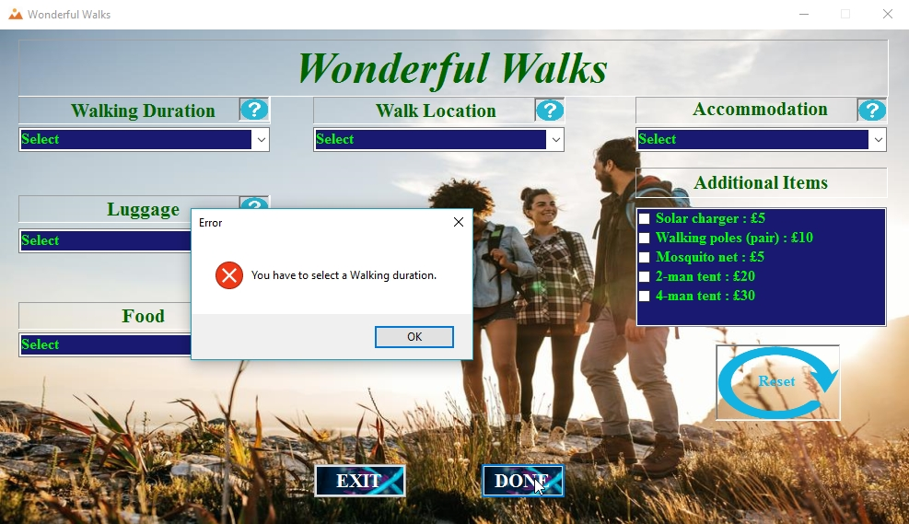

Figure 5

1. **Testing Button “DONE”:**

|  |  |  |  |
| --- | --- | --- | --- |
| **Prefix** | **Objectives** | **Testing Procedure** | **Result** |
| btnDONE | Checking whether the Button “DONE” works well or not. | Selected the necessary items form the page and clicked the button “DONE” to complete selection. | Button “DONE” works well. Message box shows up with the summary of choice and their total price. |

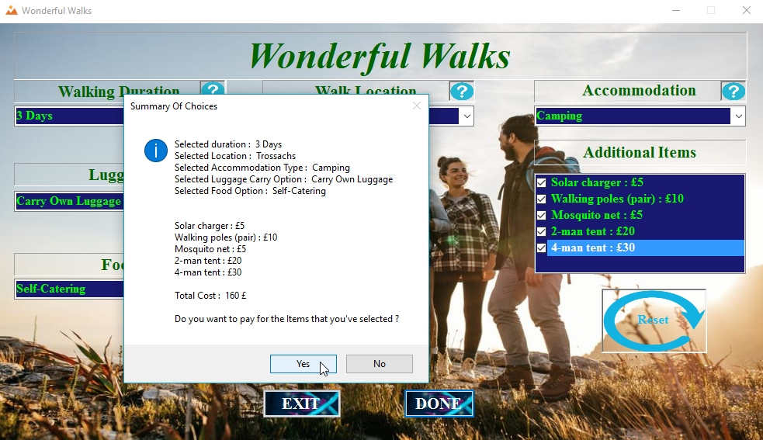

Figure 6

1. **Testing The “Yes” Button form the Message Box:**

|  |  |  |  |
| --- | --- | --- | --- |
| **Prefix** | **Objectives** | **Testing Procedure** | **Result** |
| Message Box “Yes” button. | Checking whether the message Box Button “Yes” works or not. | Clicking the “Yes” button from the message box which showed up after the successful button click on button “DONE”. | Button “Yes” worked. New message box showed up thanking the user and asking them to fill out the next form. |

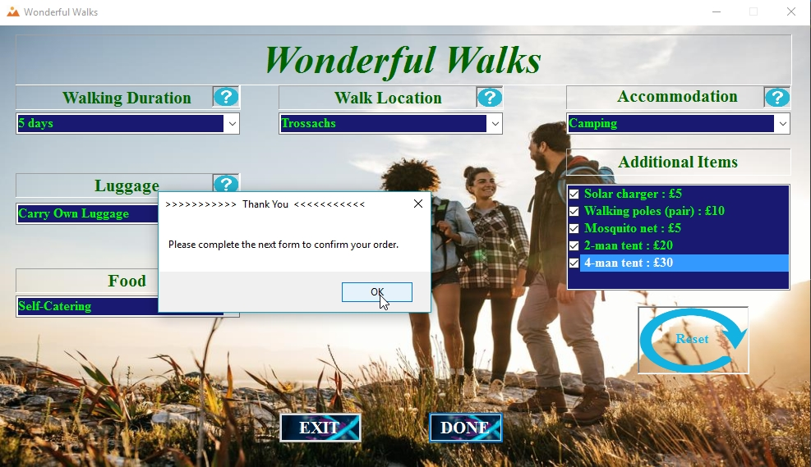

Figure 7

|  |  |  |  |
| --- | --- | --- | --- |
| **Prefix** | **Objectives** | **Testing Procedure** | **Result** |
| btnEXIT | Checking whether the Button “EXIT” works or not. | Clicking the “EXIT” button from the Selection page. | Button “EXIT” works well. The form stops running when Button “EXIT” is clicked showing a message box: “Thanks for visiting Wonderful Walks”. |

1. **Testing button “EXIT”:**

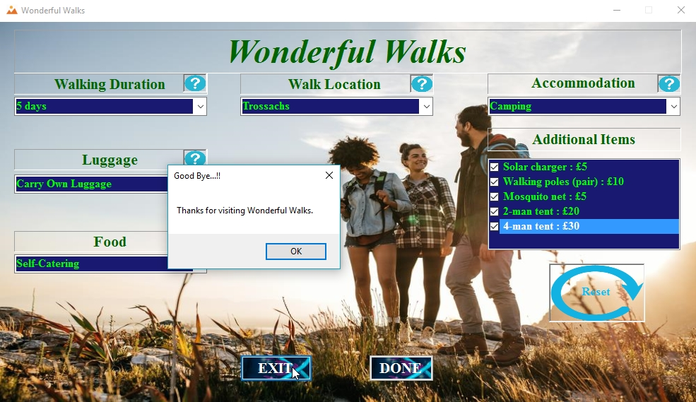

Figure 8

1. **Picture Box Click Test:**

|  |  |  |  |
| --- | --- | --- | --- |
| **Prefix** | **Objectives** | **Testing Procedure** | **Result** |
| Picture Box | To check if Picture Box works when the picture box is clicked and all the combo box rest. | Bringing the mouse arrow over the picture box of help image. | Picture box works exactly how it was expected and all the combo boxes rest. |



Figure 9

1. **Testing 3 days walking Duration stock’s availability:**

|  |  |  |  |
| --- | --- | --- | --- |
| **Prefix** | **Objectives** | **Testing Procedure** | **Result** |
| 3 days walking stock | To check if 3 days walking duration is available or not. | Have to complete the selection selecting 3 days walking duration for 16 time until the message box shows up. | After 16th time selecting the same 3 days walking duration the warning message box shows up and asks to select another category. |

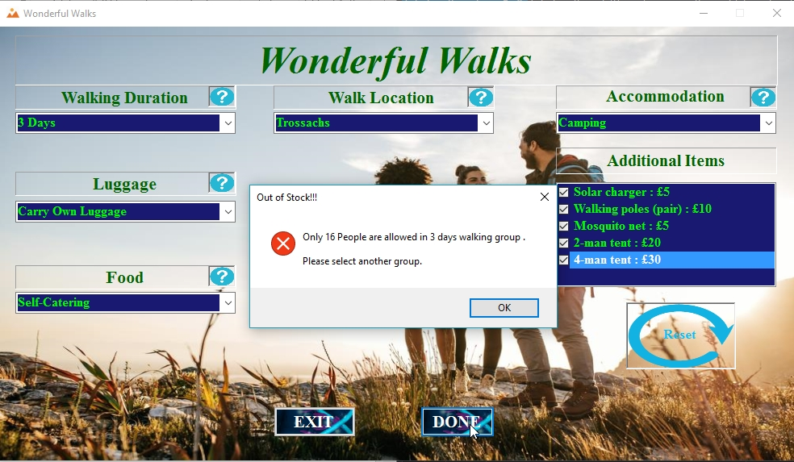

Figure 10

1. **Testing 5 days walking duration stock:**

|  |  |  |  |
| --- | --- | --- | --- |
| **Prefix** | **Objectives** | **Testing Procedure** | **Result** |
| 5 days walking stock | To check if 5 days walking duration is available or not. | Have to complete the selection selecting 5 days walking duration for 16 time until the message box shows up. | After 16th time selecting the same 5 days walking duration the warning message box shows up and asks to select another category. |

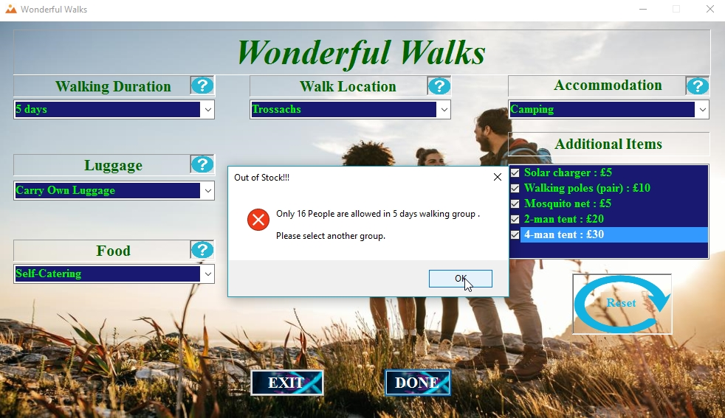

Figure 11

1. **Testing 10 days walking duration stock:**

|  |  |  |  |
| --- | --- | --- | --- |
| **Prefix** | **Objectives** | **Testing Procedure** | **Result** |
| 10 days walking stock | To check if 10 days walking duration is available or not. | Have to complete the selection selecting 10 days walking duration for 16 time until the message box shows up. | After 16th time selecting the same 10 days walking duration the warning message box shows up and asks to select another category. |

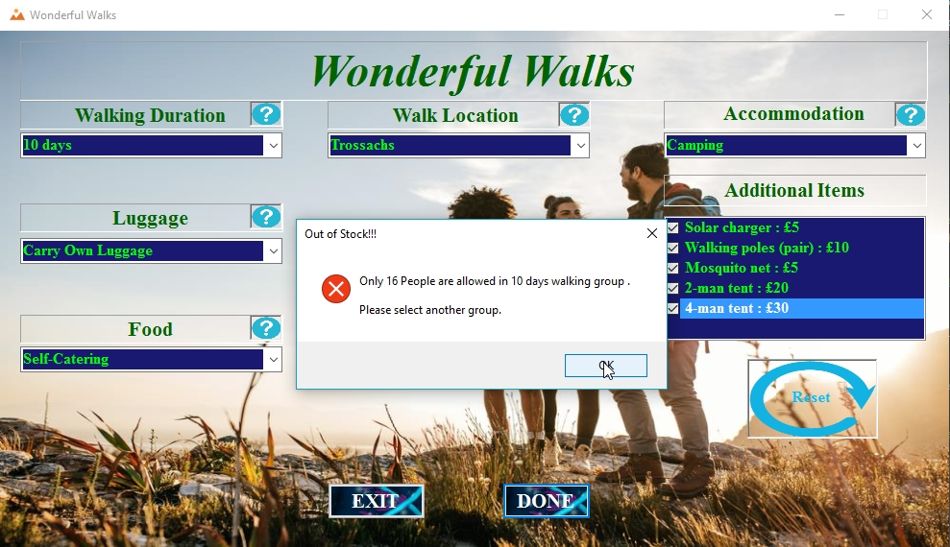

Figure 12

1. **Testing customer’s full name input text box:**

|  |  |  |  |
| --- | --- | --- | --- |
| **Prefix** | **Objectives** | **Testing Procedure** | **Result** |
| Text Box (Full Name) | To check it responses to the blank text box. | Leaving the text box empty user have to click the submit button. | After clicking the submit button an error icon will show up as warning beside the text box indicating the error and will show error reason while mouse is hovered over the icon. |

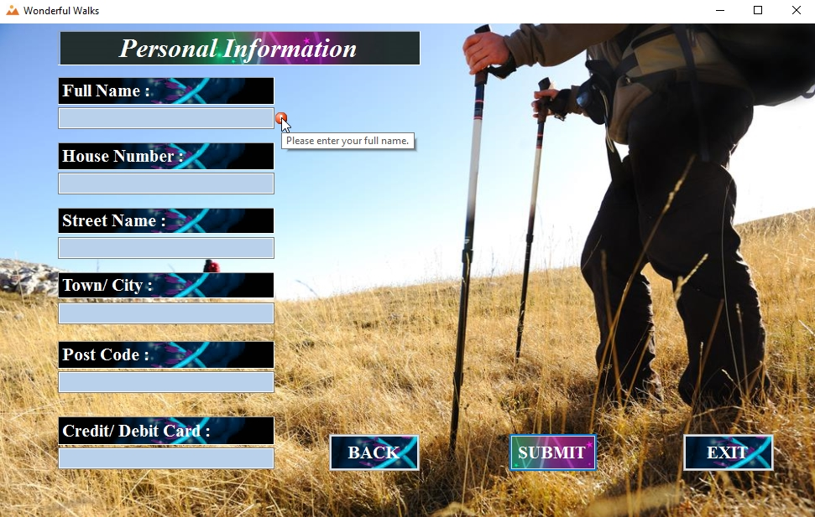

Figure 13

1. **Testing customer’s full name data type in text box:**

|  |  |  |  |
| --- | --- | --- | --- |
| **Prefix** | **Objectives** | **Testing Procedure** | **Result** |
| Text Box (Full Name) | To check it responses to the numeric data type input. | User have to input numeric data in the text box and click the submit button. | After clicking the submit button an error icon will show up as warning beside the text box indicating the error and will show error reason while mouse is hovered over the icon. |

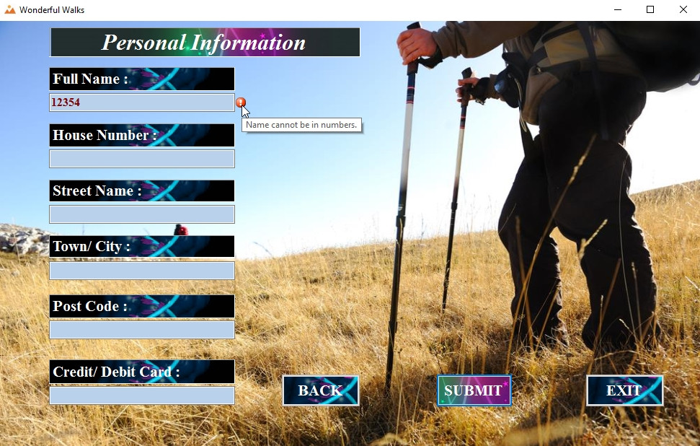

Figure 14

1. **Testing the text length of the text box:**

|  |  |  |  |
| --- | --- | --- | --- |
| **Prefix** | **Objectives** | **Testing Procedure** | **Result** |
| Text Box (Full Name) | To check the limit of the inputted text in the text box. | Alphabets should be less than 4 characters or more than 20 characters. | After clicking the submit button an error icon will show up as warning beside the text box indicating the error and will show error reason while mouse is hovered over the icon. |

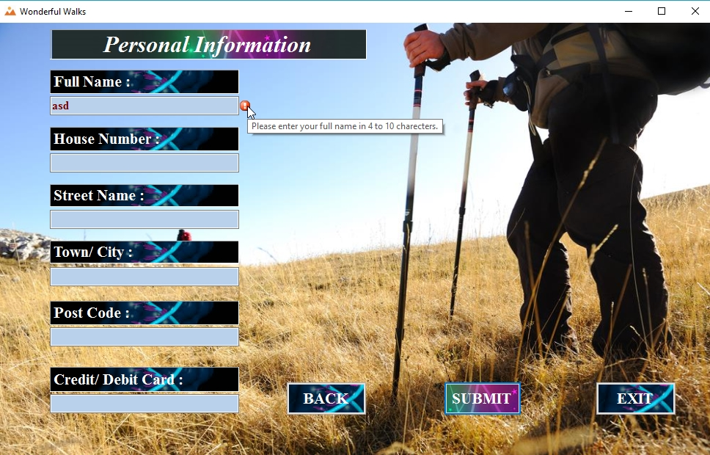

Figure 15

1. **Testing the empty house number text box:**

|  |  |  |  |
| --- | --- | --- | --- |
| **Prefix** | **Objectives** | **Testing Procedure** | **Result** |
| Text Box (House number) | To check it responses to the blank text box. | Leaving the text box empty user have to click the submit button. | After clicking the submit button an error icon will show up as warning beside the text box indicating the error and will show error reason while mouse is hovered over the icon. |

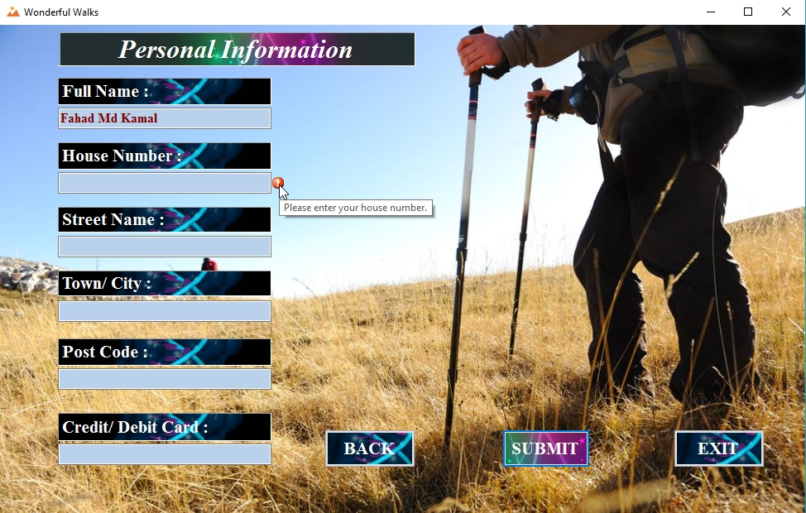

Figure 16

1. **Testing the house number text box text length:**

|  |  |  |  |
| --- | --- | --- | --- |
| **Prefix** | **Objectives** | **Testing Procedure** | **Result** |
| Text Box (House number) | To check the limit of the inputted text in the text box. | Alphabets or numbers should be less than 4 characters or more than 20 characters. | After clicking the submit button an error icon will show up as warning beside the text box indicating the error and will show error reason while mouse is hovered over the icon. |

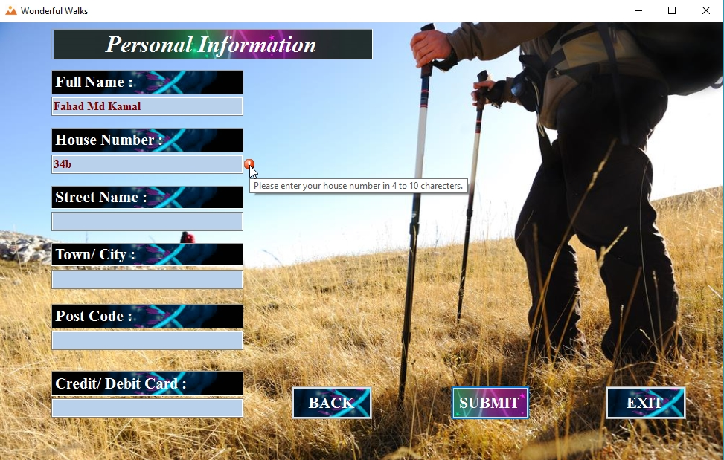

Figure 17

1. **Testing the empty street name text box:**

|  |  |  |  |
| --- | --- | --- | --- |
| **Prefix** | **Objectives** | **Testing Procedure** | **Result** |
| Text Box (Street Name) | To check it responses to the blank text box. | Leaving the text box empty user have to click the submit button. | After clicking the submit button an error icon will show up as warning beside the text box indicating the error and will show error reason while mouse is hovered over the icon. |

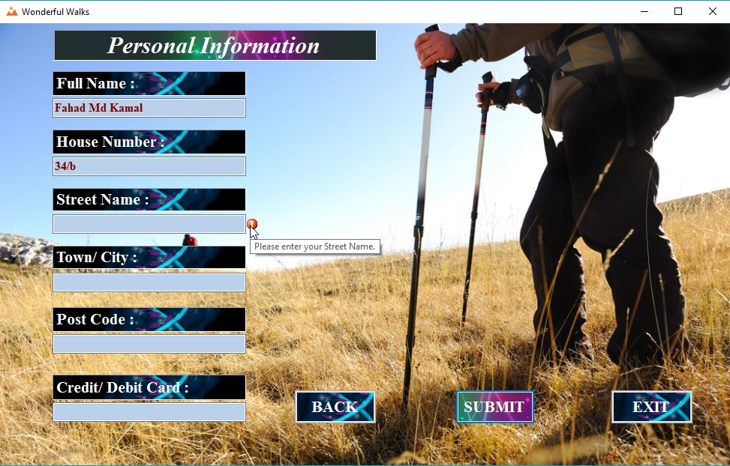

Figure 18

1. **Testing the street name text box text length:**

|  |  |  |  |
| --- | --- | --- | --- |
| **Prefix** | **Objectives** | **Testing Procedure** | **Result** |
| Text Box (Street name) | To check the limit of the inputted text in the text box. | Alphabets or numbers should be less than 4 characters or more than 20 characters. | After clicking the submit button an error icon will show up as warning beside the text box indicating the error and will show error reason while mouse is hovered over the icon. |

Figure 19: Testing the text length of the street name text box.

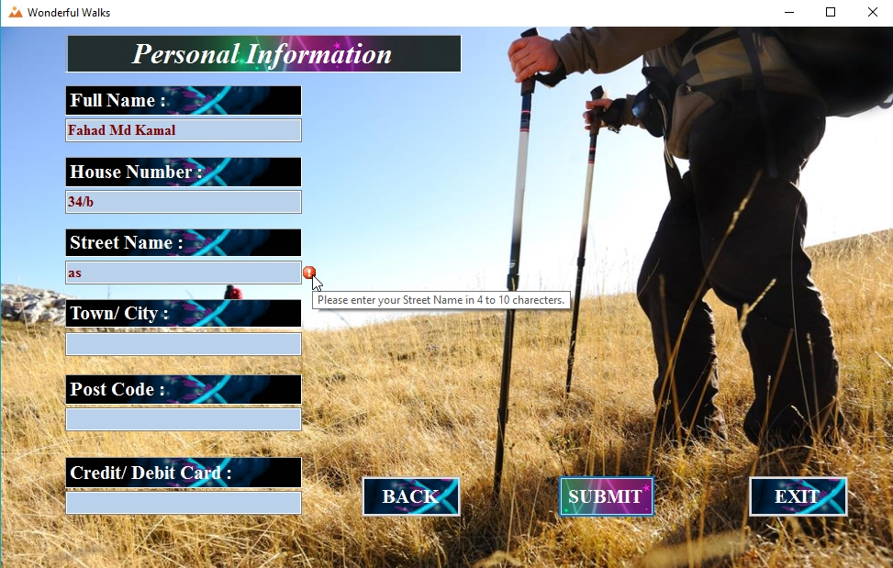

Figure 20

1. **Testing the empty Town/ City text box:**

|  |  |  |  |
| --- | --- | --- | --- |
| **Prefix** | **Objectives** | **Testing Procedure** | **Result** |
| Text Box (Town/ City) | To check it responses to the blank text box. | Leaving the text box empty user have to click the submit button. | After clicking the submit button an error icon will show up as warning beside the text box indicating the error and will show error reason while mouse is hovered over the icon. |

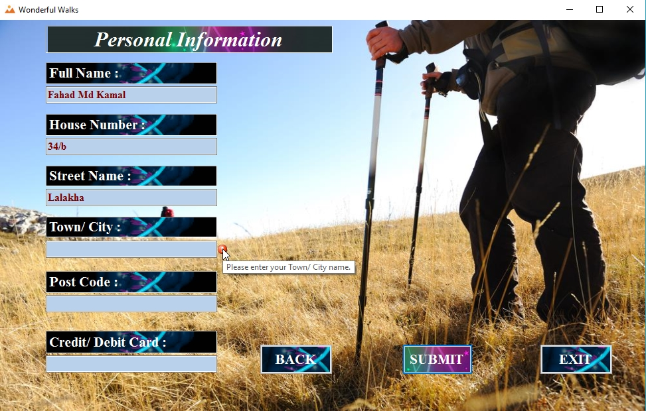

Figure 21

1. **Testing the Town/ City name text box text length:**

|  |  |  |  |
| --- | --- | --- | --- |
| **Prefix** | **Objectives** | **Testing Procedure** | **Result** |
| Text Box (Town/ City) | To check the limit of the inputted text in the text box. | Alphabets or numbers should be less than 4 characters or more than 20 characters. | After clicking the submit button an error icon will show up as warning beside the text box indicating the error and will show error reason while mouse is hovered over the icon. |

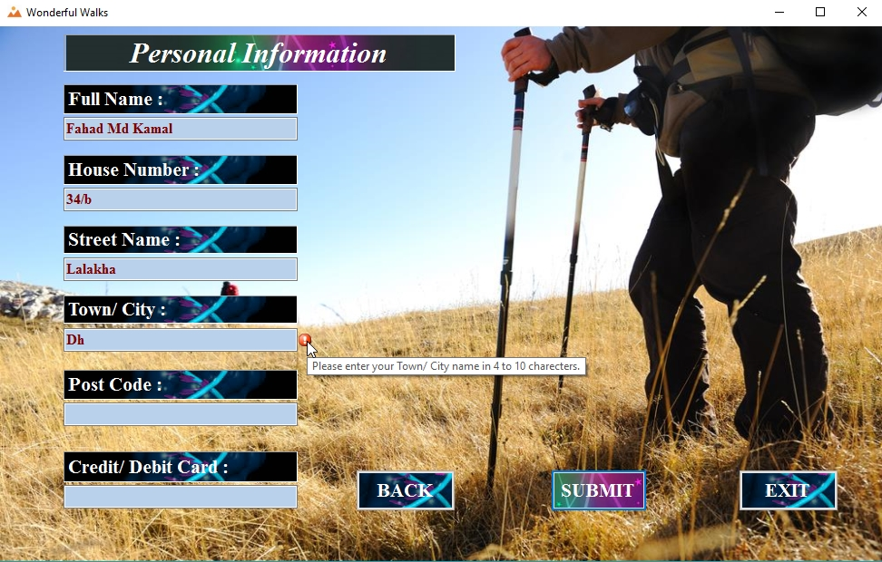

Figure 22

1. **Testing the empty post code text box:**

|  |  |  |  |
| --- | --- | --- | --- |
| **Prefix** | **Objectives** | **Testing Procedure** | **Result** |
| Text Box (post code) | To check it responses to the blank text box. | Leaving the text box empty user have to click the submit button. | After clicking the submit button an error icon will show up as warning beside the text box indicating the error and will show error reason while mouse is hovered over the icon. |

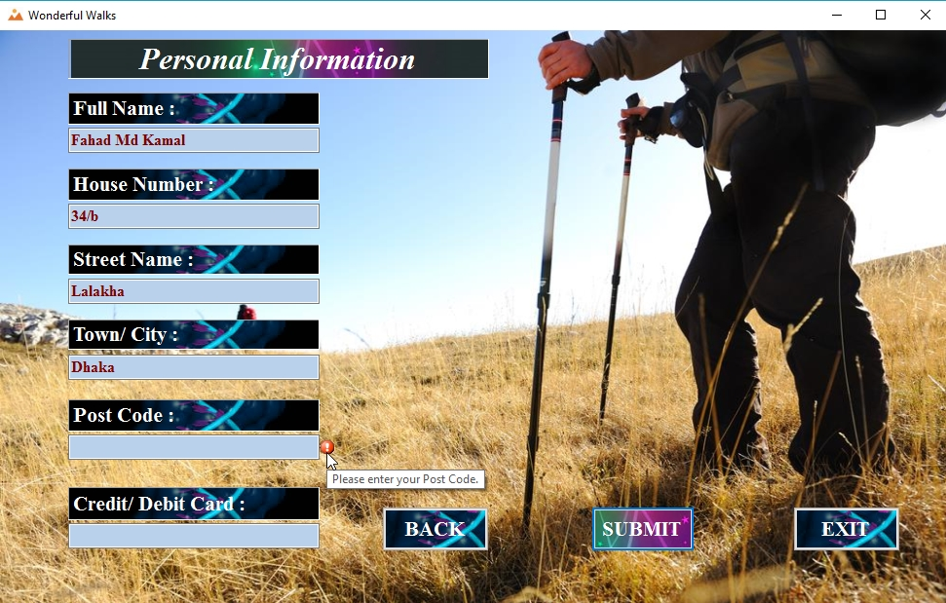

Figure 23

1. **Testing the length of post code:**

|  |  |  |  |
| --- | --- | --- | --- |
| **Prefix** | **Objectives** | **Testing Procedure** | **Result** |
| Text Box (post code) | To check the limit of the inputted text in the text box. | Numbers should be less than 4 characters or more than 10 characters. | After clicking the submit button an error icon will show up as warning beside the text box indicating the error and will show error reason while mouse is hovered over the icon. |

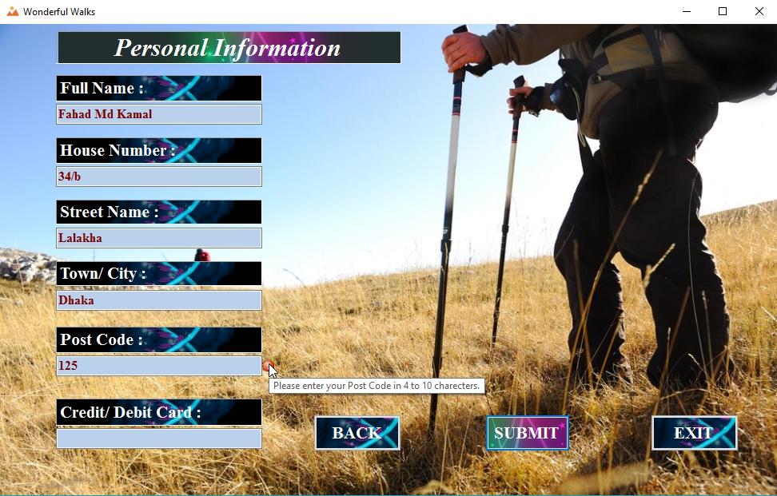

Figure 24

1. **Testing the space in post code text box:**

|  |  |  |  |
| --- | --- | --- | --- |
| **Prefix** | **Objectives** | **Testing Procedure** | **Result** |
| Text Box (post code) | To check the white space in the text box. | User have to leave a white space inside the text in restricted characters. | After clicking the submit button an error icon will show up as warning beside the text box indicating the error and will show error reason while mouse is hovered over the icon. |

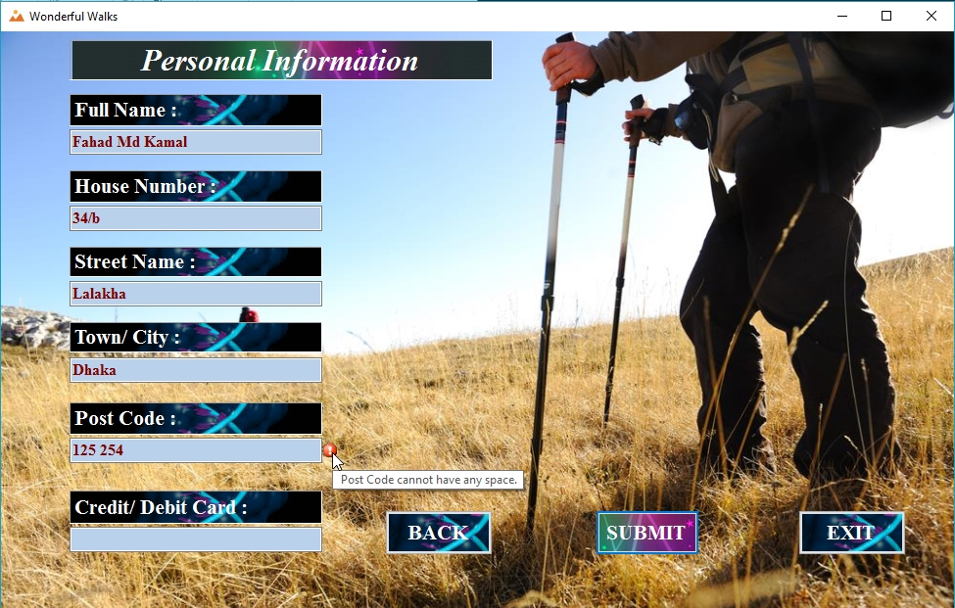

Figure 25

1. **Testing the data type of post code text box:**

|  |  |  |  |
| --- | --- | --- | --- |
| **Prefix** | **Objectives** | **Testing Procedure** | **Result** |
| Text Box (post code) | To check it responses to the numeric data type input. | User have to input numeric data in the text box and click the submit button. | After clicking the submit button an error icon will show up as warning beside the text box indicating the error and will show error reason while mouse is hovered over the icon. |

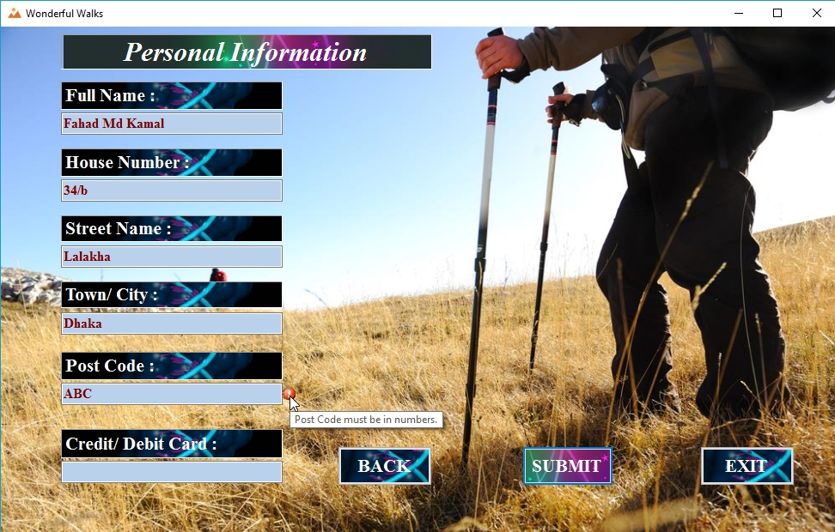

Figure 26

1. **Testing the empty credit/ debit card number text box:**

|  |  |  |  |
| --- | --- | --- | --- |
| **Prefix** | **Objectives** | **Testing Procedure** | **Result** |
| Text Box (credit/ debit card number) | To check it responses to the blank text box. | Leaving the text box empty user have to click the submit button. | After clicking the submit button an error icon will show up as warning beside the text box indicating the error and will show error reason while mouse is hovered over the icon. |

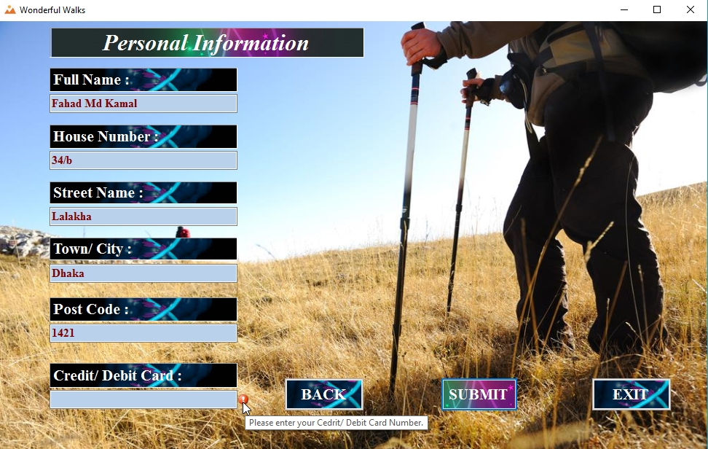

Figure 27

1. **Testing the length of credit/ debit card number:**

|  |  |  |  |
| --- | --- | --- | --- |
| **Prefix** | **Objectives** | **Testing Procedure** | **Result** |
| Text Box (credit/ debit card number) | To check the limit of the inputted text in the text box. | Numbers more or less than 16 digits. | After clicking the submit button an error icon will show up as warning beside the text box indicating the error and will show error reason while mouse is hovered over the icon. |

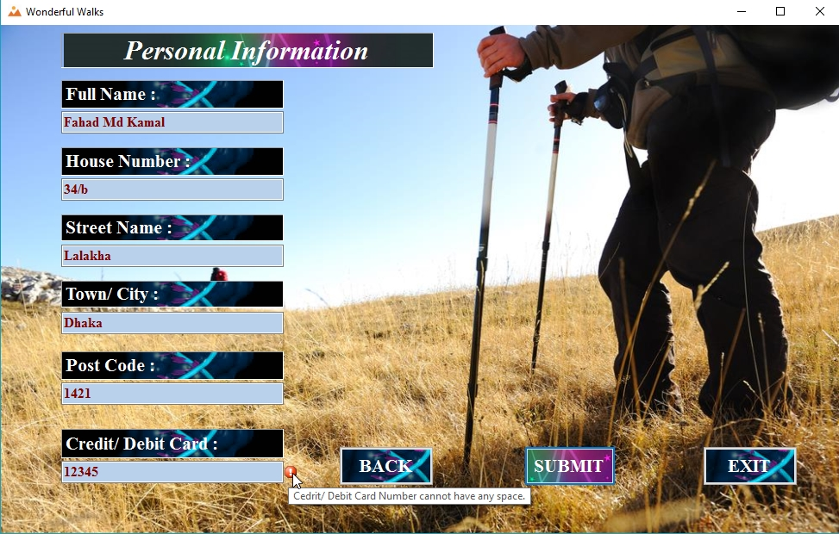

Figure 28

1. **Testing the space in credit/ debit card number text box:**

|  |  |  |  |
| --- | --- | --- | --- |
| **Prefix** | **Objectives** | **Testing Procedure** | **Result** |
| Text Box (credit/ debit card number) | To check the white space in the text box. | User have to leave a white space inside the text in restricted characters. | After clicking the submit button an error icon will show up as warning beside the text box indicating the error and will show error reason while mouse is hovered over the icon.. |

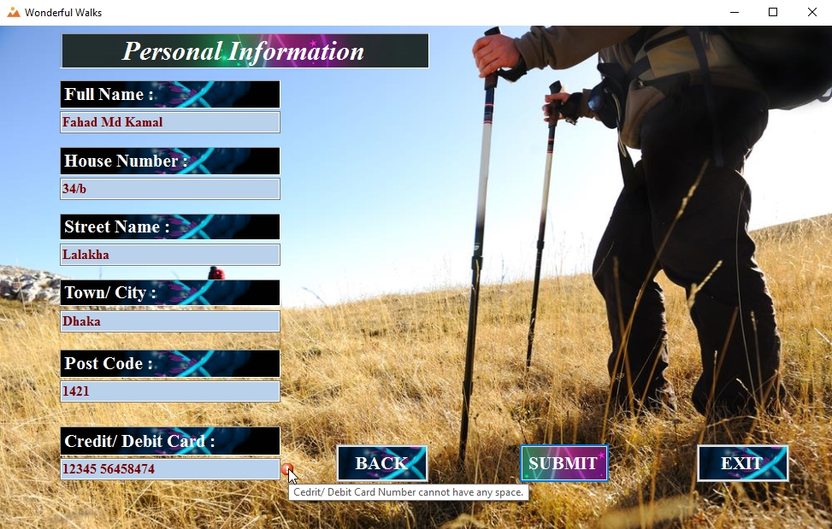

Figure 29

1. **Testing the data type of credit/ debit card number text box:**

|  |  |  |  |
| --- | --- | --- | --- |
| **Prefix** | **Objectives** | **Testing Procedure** | **Result** |
| Text Box (credit/ debit card number) | To check it responses to the numeric data type input. | User have to input numeric data in the text box and click the submit button. | After clicking the submit button an error icon will show up as warning beside the text box indicating the error and will show error reason while mouse is hovered over the icon. |

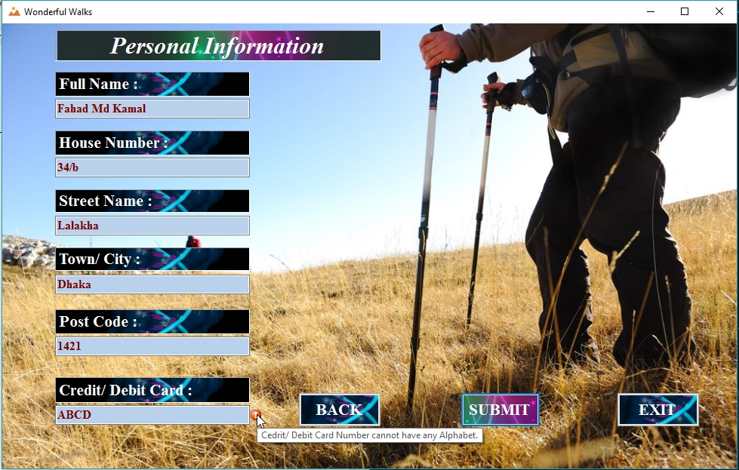

Figure 30

1. **Testing the button “SUBMIT”:**

|  |  |  |  |
| --- | --- | --- | --- |
| **Prefix** | **Objectives** | **Testing Procedure** | **Result** |
| btnSUBMIT | Checking whether the Button “SUBMIT” works or not. | User have to click the “SUBMIT” button after all the information are accordingly given. | Button “SUBMIT” works well. A message box shows up Thanking the user for purchasing the product. |

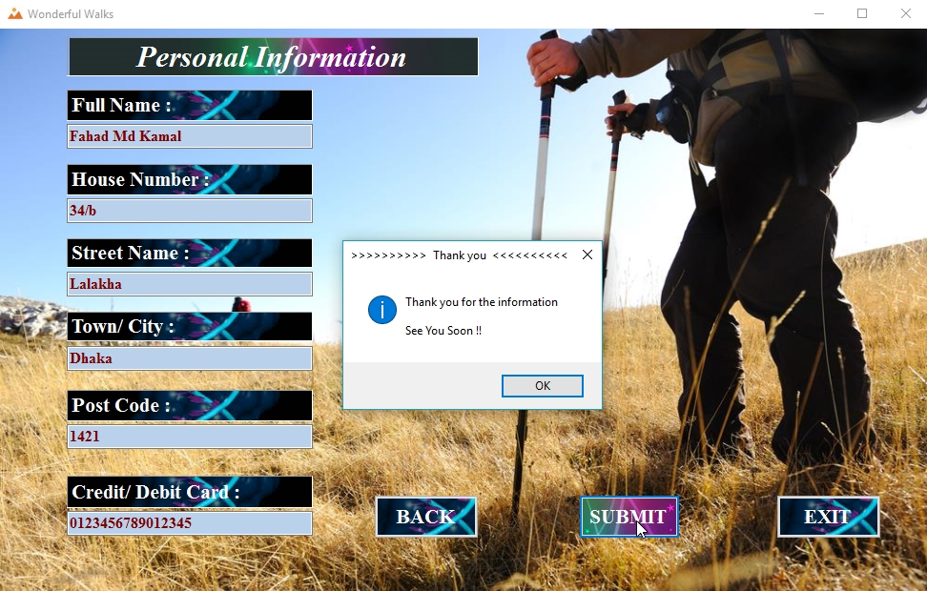

Figure 31

1. **Testing the button “BACK”:**

|  |  |  |  |
| --- | --- | --- | --- |
| **Prefix** | **Objectives** | **Testing Procedure** | **Result** |
| btnBACK | Checking whether the Button “BACK” works or not. | User have to click the “BACK” button any time to go back to the previous page/ form. | Button “BACK” works well. Informing the user Personal information page hides and the Selection page appears. |

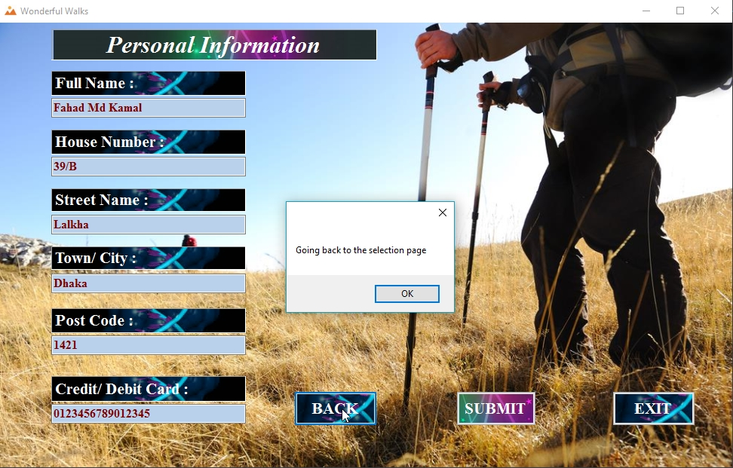

Figure 32

**Conclusion:**

“WONDERFUL WALKS” project is to provide the customer service according to the customers need. It was implemented to serve the customer according to their expected services from the lists available in the wonderful walks application. However, I have really enjoyed working for the projects because I have learned many coding and designing to implement this application. In fact, this assignment really helped me to do the documentation job for a project. Moreover, I have learnt to use Visual Studio to make a program using Visual Basic programming language.

|  |
| --- |
| **THE END** |